1. feature-based ablation experiment

Considering the influence of different features on the model performance, the ablation experiment based on different features were designed to study the information complementarity between two different features. The experimental results showed that the fusion features of the two can significantly improve the robustness and accuracy of the model. The AUC are shown in Figure 1.

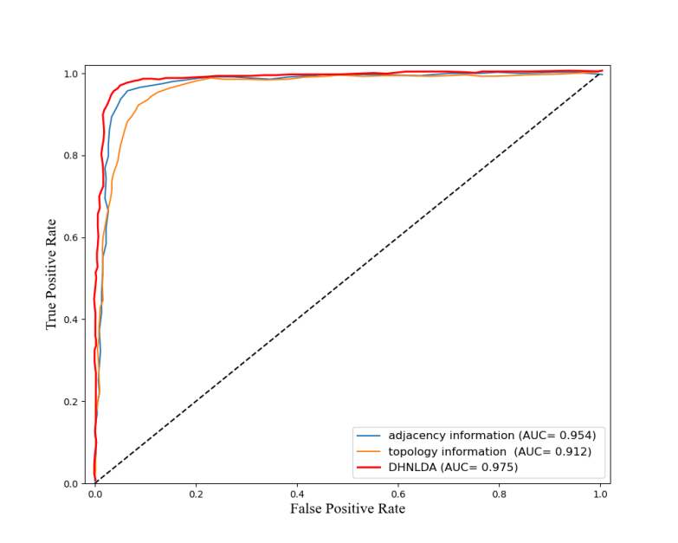

Figure 1. The AUC curves of the ablation experiment.

2. Negative sample analysis

We added new comparative experiments according to the suggestions of reviewers. In this paper, the pairs between lncRNAs and diseases without interaction were treated as negative samples. We generated the same number of negative samples as known positive samples to obtain a balanced samples. However, positive samples and negative samples are not balanced most of time. Therefore, we try to explore the performance of DHNLDA in the different sample ratios. β records the different ratios between negative samples and positive samples and ranged from 0.25, 0.5, 1.0, 2.0 to 4.0. Table 1 shows the experimental results. Although the dataset is not balanced, DHNLDA could still obtain excellent results. When the ratio β is 1.0, DHNLDA has a higher AUC value. The unbalanced samples experiments show that DHNLDA is a robust and reliable model to predict potential lncRNA-disease associations.

Table 1. Different β in negative sample generation.

|  |  |  |  |  |  |  |
| --- | --- | --- | --- | --- | --- | --- |
| β | adjacency information | topology information | Number of Positive Samples | Number of Negative Samples | AUC | AUPR |
| 0.25 | √ | √ | 2697 | 674 | 0.930 | 0.916 |
| 0.5 | √ | √ | 2697 | 1348 | 0.952 | 0.923 |
| 1.0 | √ | √ | 2697 | 2697 | 0.975 | 0.971 |
| 2.0 | √ | √ | 2697 | 5394 | 0.968 | 0.945 |
| 4.0 | √ | √ | 2697 | 10788 | 0.971 | 0.951 |
| 0.25 | √ | × | 2697 | 674 | 0.897 | 0.876 |
| 0.5 | √ | × | 2697 | 1348 | 0.925 | 0.902 |
| 1.0 | √ | × | 2697 | 2697 | 0.954 | 0.933 |
| 2.0 | √ | × | 2697 | 5394 | 0.939 | 0.915 |
| 4.0 | √ | × | 2697 | 10788 | 0.949 | 0.896 |
| 0.25 | × | √ | 2697 | 674 | 0.846 | 0.815 |
| 0.5 | × | √ | 2697 | 1348 | 0.875 | 0.853 |
| 1.0 | × | √ | 2697 | 2697 | 0.912 | 0.923 |
| 2.0 | × | √ | 2697 | 5394 | 0.891 | 0.871 |
| 4.0 | × | √ | 2697 | 10788 | 0.887 | 0.869 |

1. Model complexity

The details of parameters for our model as shown in Table 2.

Table 2 Hyper-parameters of DHNLDA

|  |  |
| --- | --- |
| Name | value |
| Number of encoder layers (SAE) | 3 |
| Number of decoder layers (SAE) | 3 |
| Size of each layer in SAE | 128, 64, 32 |
| Kernel sizes of multi-scale CNN | 1, 3, 5 |
| Filters | 64 |
| Fully connected layers | 32 |
| Learning rate | 0.001 |
| Epoch | 40 |
| Batch Size | 256 |
| Dropout | 0.2 |

Total params: 3021538

Trainable params: 3020258

In addition, the specific experimental parameter settings are shown in section 4.1, page 5.

In the model design, the experiment sets the dropout for each layer of the network and randomly eliminates some network nodes to simplify the model and to avoid the problem of overfitting. In the model training, the early stop strategy is adopted to prevent the influence of overfitting by limiting the number of iterations. The loss of the experiment is shown in Figure 2.

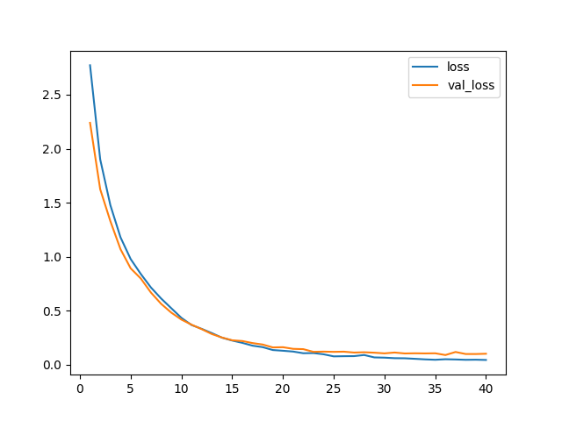

Figure 2. The loss curves of the model.